1.
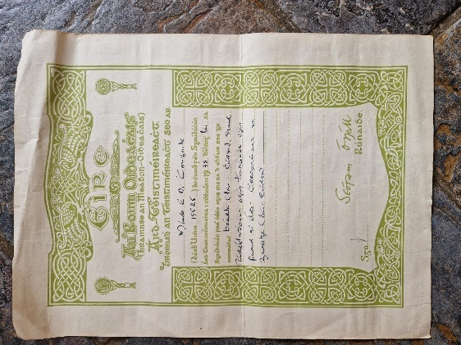
An Roinn Oideachais. Leaving Cert Results 1938 (Courtesy of Mary Dolan)

2.
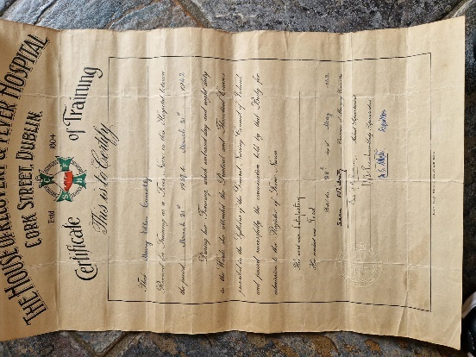
The House of Recovery and Fever Hospital, Cork Street, Dublin.
Certificate of Training 28th of May, 1942. (Courtesy of Mary Dolan)
3.
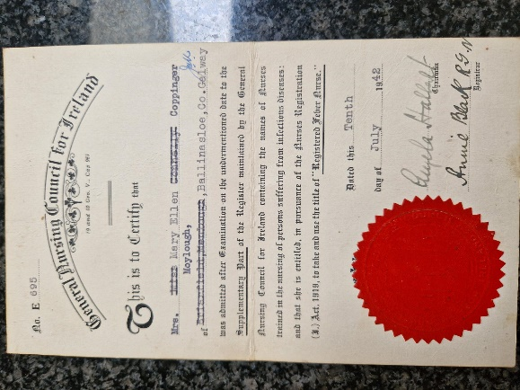
General Nursing Council for Ireland, “Registered Fever Nurse” Certificate, 10th of July, 1942. (Courtesy of Mary Dolan)

4.
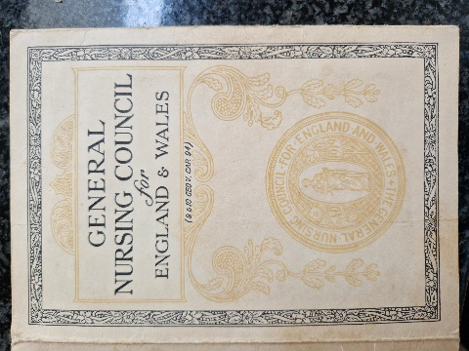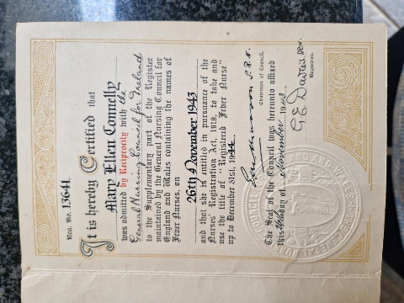
General Nursing Council for England and Wales. “Registered Fever Nurse” Certificate,
28th of November,1943. (Courtesy of Mary Dolan)

5.
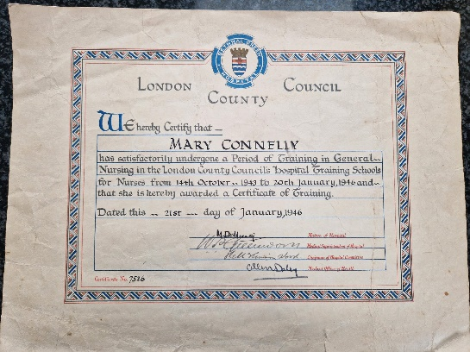
London County Council “Certificate of Training in General Nursing” 21st of January, 1946. (Courtesy of Mary Dolan)

6.
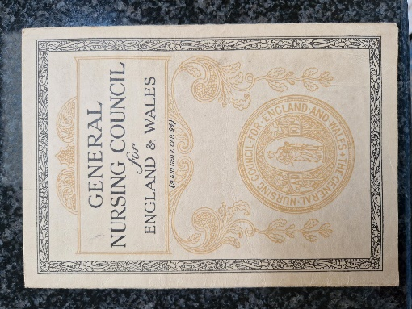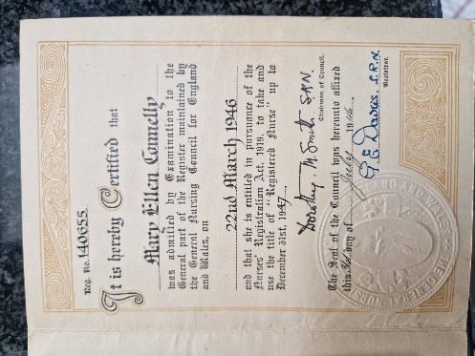
General Nursing Council for England and Wales, “Registered Nurse” Certificate
22nd of March, 1946. (Courtesy of Mary Dolan)

7.
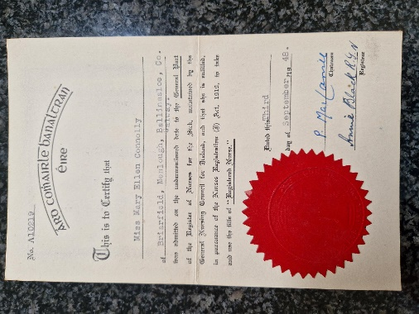
General Nursing Council for Ireland, Certificate of Registration as a Registered Nurse, 3rd of September, 1948. (Courtesy of Mary Dolan)

8.
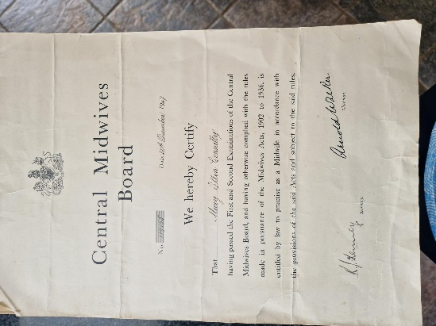
Central Midwives Board, Examination Results Certificate, 30th of December, 1947. (Courtesy of Mary Dolan)

9.
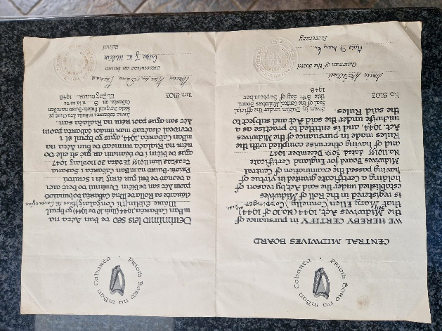
Roinn Bord na mBan Cabhartha (Central Midwives Board)
Registration as a Registered Midwife, 8th of September, 1948. (Courtesy of Mary Dolan)

10.
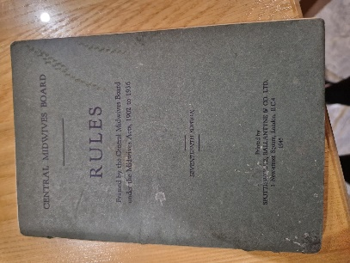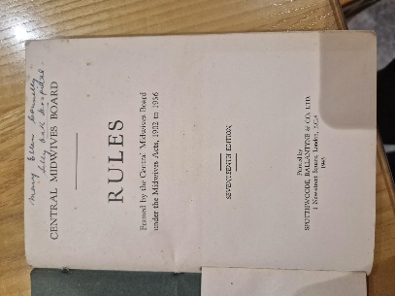
Central Midwives Board – RULES
Framed by the Central Midwives Board under the Midwives Acts, 1902 to 1936.

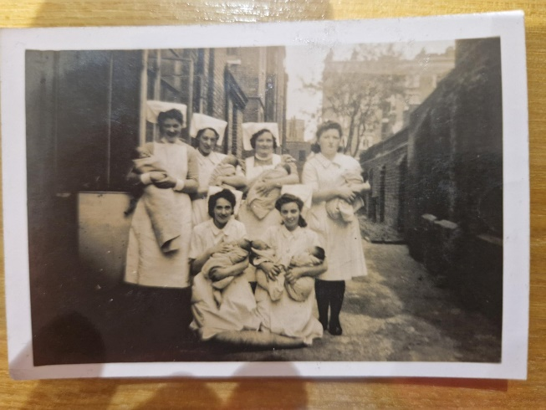
Mary Ellen is in the front, on the right (Courtesy of Mary Dolan)

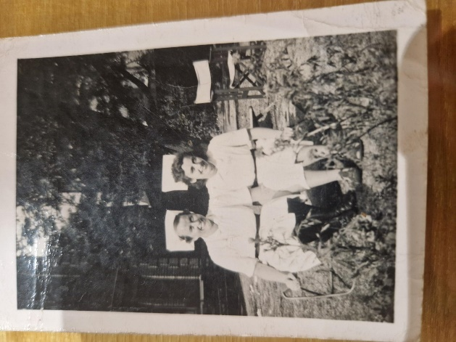
Mary Ellen is on the right. (Courtesy of Mary Dolan)

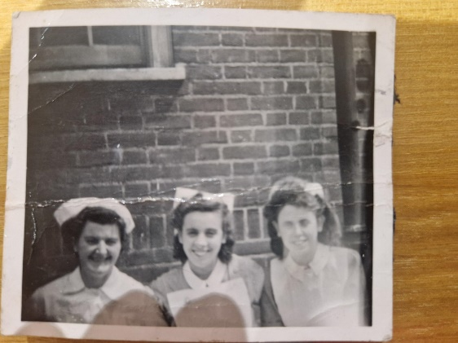
Mary Ellen is in the middle. (Courtesy of Mary Dolan)

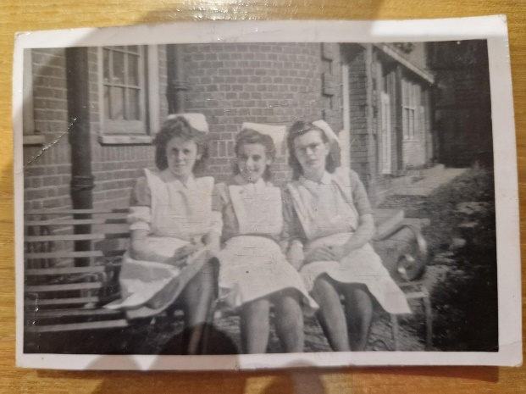
Mary Ellen is in the middle. (Courtesy of Mary Dolan)

