https://field-monuments.galwaycommunityheritage.org/content/archaeology/industrial-archaeology/crane-meelick

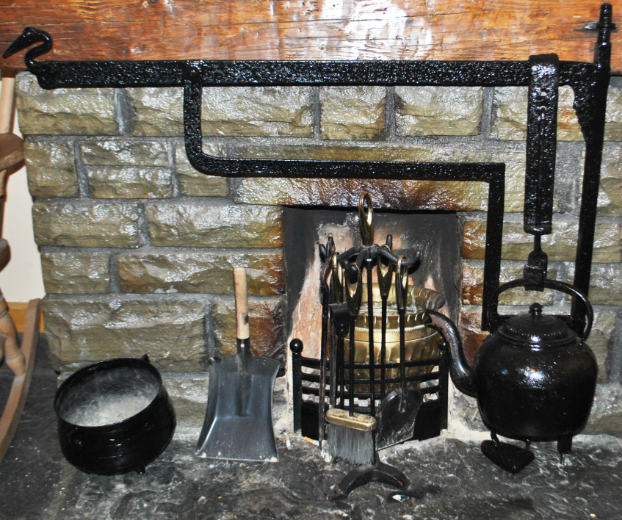

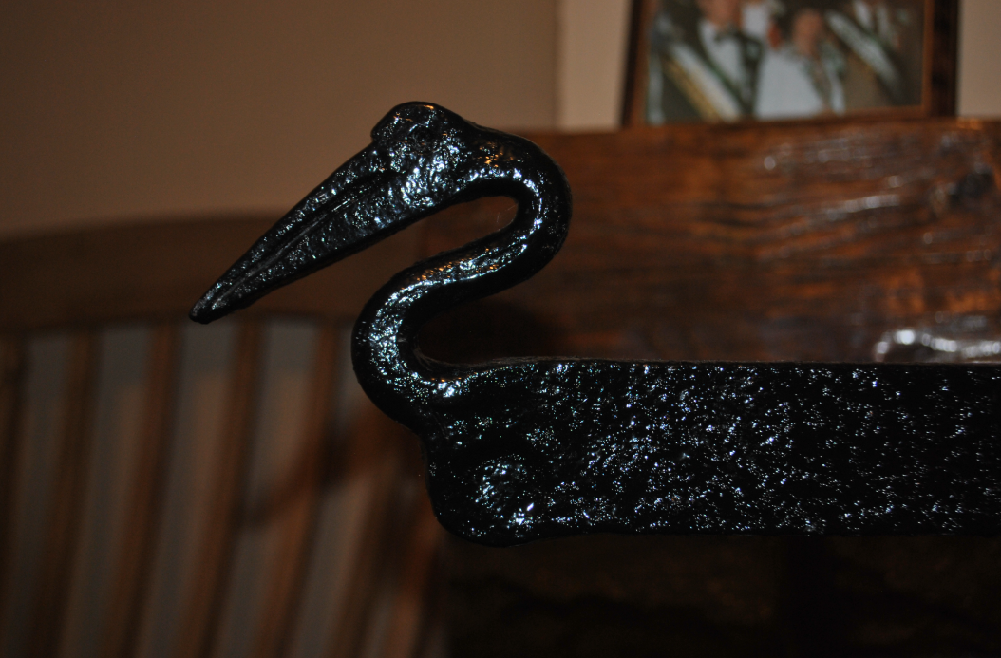
Head of a Crane, on a Crane –
Crane used as an ornate terminal to the fire crane.
Christy Cunniffe
The iron craft of the blacksmith stretched to making all sorts of items for the farm and house. This amazing crane is decorated with a crane head. It was made by the Staunton blacksmiths of Balyhue, Eyrecourt. This is a fine example showing off the skill of the master smith. My thanks to Jim Bermingham for his permission to photograph this wonderful piece of vernacular folk art. A number of items including a cast iron pot and kettle used for cooking sit on the hearth

