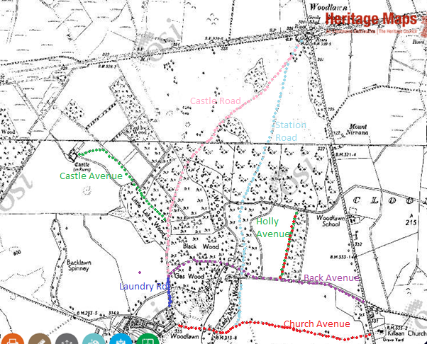
Castle Avenue, Castle Road , Station Road, Holly Avenue, Back Avenue, Church Avenue, Laundry Road, Front Avenue, Rabbit Burrow Road, Mill Hill
