Woodlawn Pathways - Some of the forgotten pathways
Woodlawn House & Estate had three main access avenues.

The Front Avenue (Brown) was the main access to Woodlawn House, used mainly by the gentry. The Back Avenue was the workers and goods access to house and farm. In addition we have discovered from the Map that there were a number of alternative pathways established around Woodlawn estate.

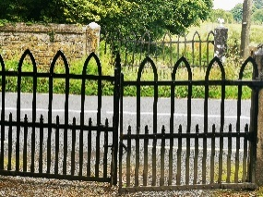
Church Avenue (Red) leading from Woodlawn House directly to the front gates of the Church of Ireland. This was a shorter way to the Church for Services. It was usually travelled by horse and carriage but in latter times, Derek Trench drove his new car on this pathway. At the end of the pathway, ornate cast iron gates were placed directly across the road from Church.

Station Avenue (Blue). This pathway leads directly to the Railway Station and the Post Office. Derek Trench sent his “Butler’s boy” each morning to collect the daily paper. His name was Trapp and on a recent visit to Woodlawn, he recounted to Tom Seale that each day he walked the avenue to May Creggs shop to collect the Irish Times and the English Times before 10am.
https://woodlawn.galwaycommunityheritage.org/content/people/woodlawn-diaspora/butlers-boy-revisits-woodlawn
Laundry Path (Blue) ran at the back of the house. There was a dedicated Laundry Room in a separate building at the rear of the house, where all washing and drying took place. This Laundry room was purpose built which included large sinks where wash boards & manual clothes wringers would be part of the wash process. Rows of wooden hangers on rails were used to hang the clothes. The laundry had its own heating system which ensured a swift drying/airing of the linen before they were brought into the main house again for re-use..
Holly Avenue (green and red)– this is a short avenue running parallel to the now main Woodlawn Road. We assume it may relate to there being Holly Tress along the path.
Rabbit Burow Road (Yellow) and Rock Bridge – name probably derives from the possibility that rabbits were plentiful and also hunted for the dinner table.* This path and Rock Bridge were on the field known as the Long Meadow situated at the front of Woodlawn House.
*See Woodlawn House Game Pie recipe here: https://woodlawn.galwaycommunityheritage.org/content/topics/galway-food-heritage-woodlawn/game-pie

Castle Avenue (Green) (off the Castle Road).

This pathway leads to what is known locally as the old Castle, or Gamekeepers Lodge. The Gamekeepers’ Lodge (Castle) is a Recorded Monument GA086:239.
The gamekeepers’ lodge can be seen to the west of the main House, on what was known as The Castle Path. It was thought to be an original ‘castle’, with its round tower which is intriguing. But the fabric which includes red brick would suggest a more recent construction date than what the overall stone-built appearance suggests. The stone may have been re-used from an earlier building.

The 1901 Census names the Gamekeeper as John Graham from Scotland, who lived here with his wife, 2 sons (also listed as Gamekeepers) and 2 daughters (registered as scholars). The Gamekeepers’ role was considered quite important as he had to raise a supply of pheasant & other game for the main House, the hunting season & training dogs.

The Gamekeeper was supplied with the house & servants. He also trained a number of apprentice Gamekeepers who lived in ‘Bothies’ or huts with dormitory type accommodation on the grounds.

Other interesting features are the Bee-hive ‘boles’ within the walled garden that ensured a supply of honey when sugar was scarce and beeswax for making candles. Traces of a wall which would have fenced in ‘the game’ are visible along the field.

Gamekeepers and their apprentices, Woodlawn Estate
By John Heuston, Courtesy of Alf Seale.

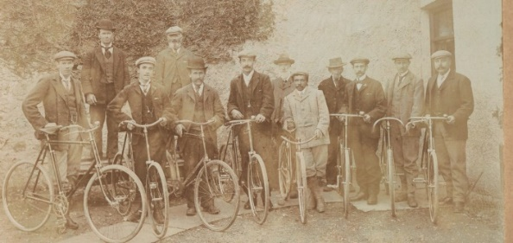

More Information available on our website www.woodlawn.galwaycommunityheritage.org

