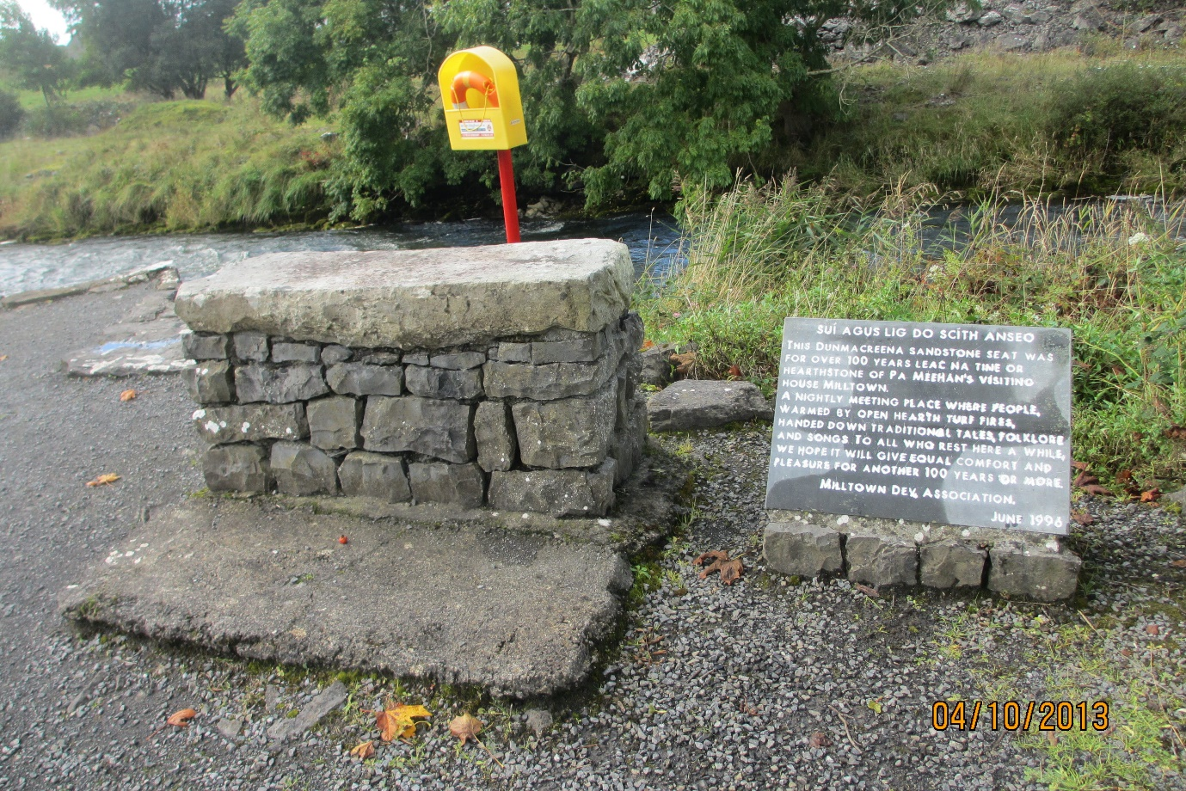
Leac Na Tine (Hearthstone) of Pa Meehan’s House, Milltown
This sandstone seat, known as Leac Na Tine or the hearthstone of Pa Meehan’s visiting house in Milltown, served as a central gathering place for over 100 years. Positioned near an open hearth, it was where families and community members came together, warmed by turf fires. Here, traditional tales, folklore, and songs were shared, preserving cultural knowledge and history in an intimate, communal setting. More than a simple seat, it was a symbol of connection, storytelling, and cultural exchange. The hearthstone continues to serve as a place for people to gather, ensuring the legacy of this tradition endures for generations to come.

